Multiple-choice section

|  |  |  |  |  |  |  |
| --- | --- | --- | --- | --- | --- | --- |
| Question | 1 | 2 | 3 | 4 | 5 | 6 |
| Answer | A | B | C | D | C | D |

Question 1 [7.1]

A

Mark the letters O, A and H on the diagram.

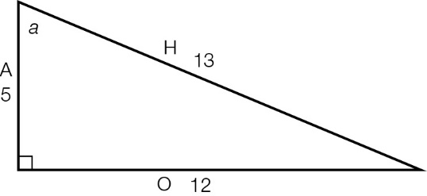



Question 2 [7.2]

B

Mark the letters O, A and H on the diagram.

|  |  |
| --- | --- |
| ACPM9_PR_7_02wssa | sin(θ) ==  =  *x* = × 27  *x* = 9 |

Question 3 [7.3]

C

Mark the letters O, A and H on the diagram.

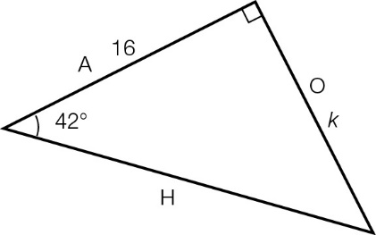

O and A can be used with the tan ratio: tan(42°) =

Question 4 [7.5]

D

|  |  |
| --- | --- |
| ACPM9_PR_7_05wssa | tan(49°) = , so *k* =  *k* = 8.3 m |

Question 5 [7.5]

C

138°T is between E (90°) and S (180°). It is 42°E of S (180° − 38° = 42°), so it’s written as S42°E.

Question 6 [7.4]

D

Mark the letters O, A and H on the diagram.

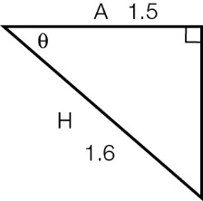

A and H are used, so use the cosine ratio: θ = cos-1

Multiple-choice total marks: 6

Short answer section

Question 7 4 marks [7.3]

**(a)**

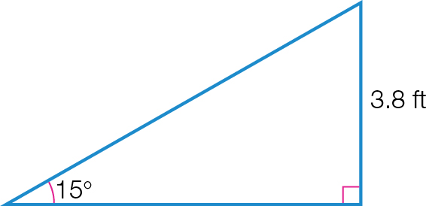

|  |  |
| --- | --- |
| **(b)** | sin(θ) =  θ = 15°  Opposite side = 3.8 ft  sin(15°) =    *x* = 14.7 ft |

Question 8 5 marks [7.5]

**(a)** cos(θ) = 

cos(44°) = 

*x* = 40 × cos(44°)

*x* = 28.8°

The bus travels 28.8 km north from its starting point.

**(b)** N44°W is in the top left-hand quadrant and 44° short of 360°.

true bearing = 360° – 44° = 316°T

Question 9 5 marks [7.1]

|  |  |
| --- | --- |
| **(a)**  **ACPM9_PR_7_08wssa** | **(b) (i)** sin(θ) =  **(ii)** cos(θ) =  **(iii)** tan(θ) = |

Question 10 6 marks [7.2]

|  |  |
| --- | --- |
| (a)  ACPM9_PR_7_09wsf | sin(θ) =  sin(34°) =  *x* = 5.2 × sin(34°)  *x* = 2.9 m (1 d.p.) |
| **(b)**  ACPM9_PR_7_10wsf | tan(θ) =  tan(27°) =  *b* =  *b* = 21.2 m (1 d.p.) |
| **(c)**  ACPM9_PR_7_11wssa_RR | cos(θ) =  cos(59°) =  *z* =  *z* = 6.8 (1 d.p.) |

Question 11 6 marks [7.4]

|  |  |  |
| --- | --- | --- |
| (a) sin(θ) =  θ =  θ = 52° | (b) tan(θ) =  θ =  θ = 57° | (c) cos(θ) =  θ =  θ = 57° |

Question 12 5 marks [7.2]

**(a)** *x*2 + 242 = 302

*x*2 = 302 – 242

*x*2 = 900 – 576

*x*2 = 324

*x* = 18

The opposite side is 18 cm.

**(b)** sin(θ) = 

sin(θ) = 

sin(θ) = 

cos(θ) = 

cos(θ) = 

cos(θ) = 

tan(θ) = 

tan(θ) = 

tan(θ) = 

Question 13 3 marks [7.5]

(a)

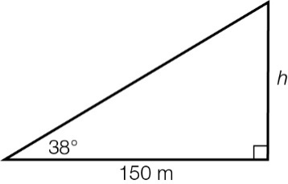

(b) tan(38°) = 

*h* = 150 × tan(38°)

*h* = 117.2 m (1 d.p.)

Question 14 3 marks [7.3]

Call the base (diameter) of the semicircle *H*.

cos(30°) = 

*H* = 

*H* = 13.279 mm

So, the radius is 6.6395 mm.

Arc length = 

= 

= 

= 20.8586

To find the perimeter we need to add the arc length to the diameter:

20.8586 + (2  6.6395) = 34.1376

The perimeter of the semicircle is 34.1 mm (1 d.p.).

Short answer total marks: 37

Extended answer section

Question 15 7 marks [7.3, 7.4]

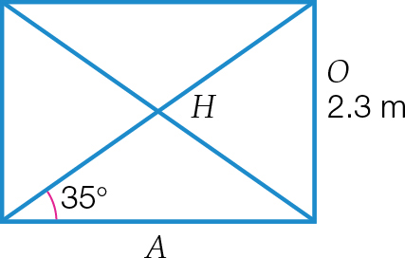

(a) Length of a horizontal beam:

tan(35°) = 

A = 

A = 3.2847 m

Length of a diagonal beam:

sin(35°) = 

H = 

H= 4.0099 m

total length of wood required = 2 × (2.3 + 3.2847 + 4.0099) = 19.19 m (2 d.p.)

(b)

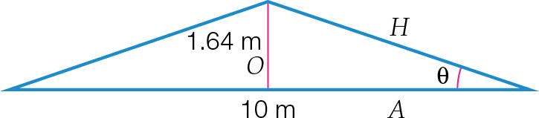

**(i)** tan(θ) = 

θ = tan -1

θ = 18.2° (1 d.p.)

**(ii)** To find the length of the diagonal beams:

sin(18.2°) = 

H = 

H = 5.251 m

total wood needed for frame 2 × 5.251 + 1.64 + 10 = 22.14 m (2 d.p.)

Question 16 6 marks [7.5]

|  |  |
| --- | --- |
| **(a)** tan(θ) =  θ = 30°  Length of adjacent side = 38 m  tan(30°) =  *h* = 38 × tan(30°)  *h* = 21.94 m | **(b)** tan(θ) =  In Δ*ADC*, tan(θ) =  *DC* = *BC* – *BD*  = 38 – 15  = 23  tan(θ) =    θ = 44° |

Extended answer total marks: 13

TOTAL test marks: 56